LAB 10: FOR LOOPS

# Name: Hassan Shahzad

# Class: BSCS 7C

# CMS ID: 211798

## Task 02:

#define _CRT_SECURE_NO_WARNINGS

#include <stdio.h>

#include <stdlib.h>

int main()

{

char message[80];

int a;

printf("Type in a message and I'll display eight times.\n");

printf("Message: ");

gets(message);

for (a = 1; a <= 8; a++)

{

printf("%s\n", message);

}

return 0;

}

## Output:

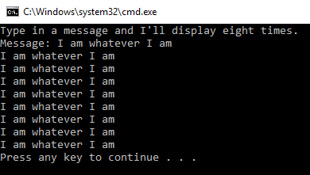

## Task 04:

#define _CRT_SECURE_NO_WARNINGS

#include <stdio.h>

#include <stdlib.h>

int main()

{

printf("x\n");

printf("------\n");

float a;

for (a = -10.0; a <= 10; a = a + 0.5)

{

printf("%.1f\n", a);

}

return 0;

}

## Output:

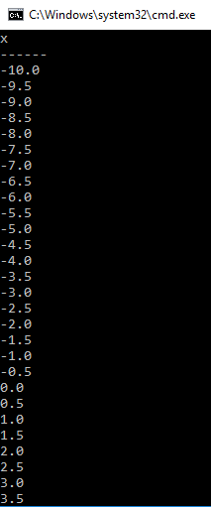 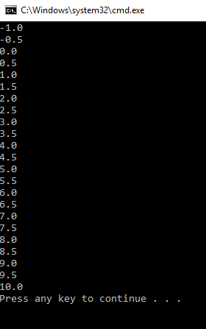

## Task 06:

#define _CRT_SECURE_NO_WARNINGS

#include <stdio.h>

#include <stdlib.h>

int main()

{

for (int a = 1; a <= 20; a++)

{

if (a % 2 != 0)

{

printf("%d\n", a);

}

if (a % 2 == 0)

{

printf("%d <\n", a);

}

}

return 0;

}

## Output:

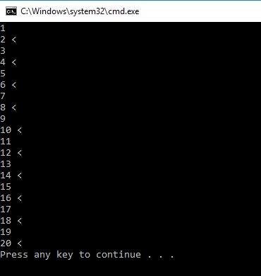

## Task 08:

#define _CRT_SECURE_NO_WARNINGS

#include <stdio.h>

#include <stdlib.h>

#include <string.h>

int main()

{

char message[100];

printf("What is your message? ");

gets(message);

printf("\nYour message is %d characters long.\n", strlen(message));

printf("The first character is at position 0 and is '%c'.\n", message[0]);

int lastpos = strlen(message) - 1;

printf("The last character is at position %d and is '%c'.\n", lastpos, message[lastpos]);

printf("\nHere are all the characters, one at a time:\n");

for (int i = 0; i < strlen(message); i++)

{

printf("\t%d - '%c'\n", i, message[i]);

}

int vowel_count = 0;

for (int i = 0; i < strlen(message); i++)

{

char letter = message[i];

if (letter == 'a' || letter == 'A' || letter == 'e' || letter == 'E' || letter == 'i' || letter == 'I' || letter == 'o' || letter == 'O' || letter == 'u' || letter == 'U')

{

vowel_count++;

}

}

printf("\nYour message contains vowel 'a, e, i, o, u' %d times.\n", vowel_count);

}

// --------------------------------------------------------------------------

// Q1): It displays an extra line an extra space.

// Q2): Length of box is 3 and the alphabet x is at position 2.

// Q3): This is because index in the case for an array starts with 0.

// Q4): message contains 7 vowels.

## Output:

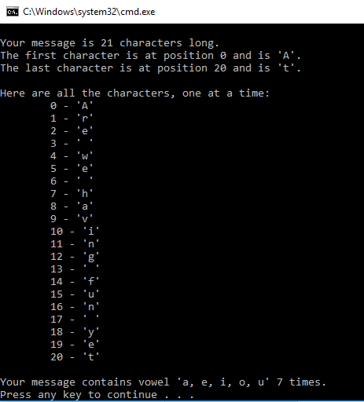

## Task 10:

#include <stdio.h>

#include <time.h>

int main()

{

int x, y, a, b, totaluser = 0, totaldealer = 0;

srand(time(NULL));

printf("Baby Blackjack\n");

x = 1 + rand() % 10;

y = 1 + rand() % 10;

totaluser = x + y;

printf("You drew a %d and %d.\n", x, y);

printf("Your total is = %d\n", totaluser);

a = 1 + rand() % 10;

b = 1 + rand() % 10;

printf("Dealer drew a %d and %d.\n", a, b);

totaldealer = a + b;

printf("Dealer's total is = %d\n", totaldealer);

if (totaluser > totaldealer)

{

printf("YOU WIN\n");

}

if (totaldealer > totaluser)

{

printf("DEALER WINS\n");

}

if (totaldealer == totaluser)

{

printf("MATCH DRAWN\n");

}

return 0;

}

## Output:

